Mercury’s date with the Sun
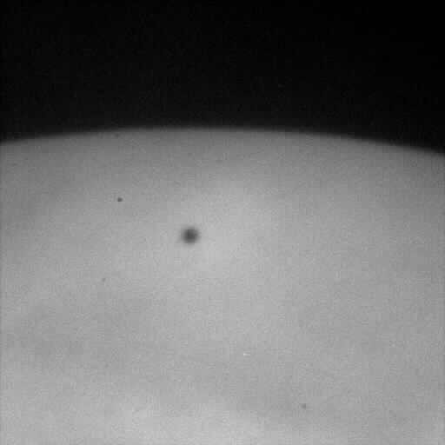
On 9th November morning, Sun would not be appearing as a white bright disk. Apart from few sunspots, get ready to see a small circular dot on the face of Sun on coming 9th November, 2006 as Mercury transit is going to happen on that day.

A transit is the passage of a planet across the Sun's bright disk. At this time, the planet can be seen as a small black disk slowly moving in front of the Sun. It is same as solar eclipse but the size of Mercury is so small and it is so far away from us that it looks like a small dot on the sun. The orbits of Mercury and Venus lie inside Earth's orbit, so they are the only planets which can pass between Earth and Sun to produce a transit. Transits are very rare astronomical events. A transit of Mercury across the Sun takes place when the planet Mercury comes between the Sun and the Earth, and Mercury is seen as a small black dot moving across the face of the Sun.

In the case of Mercury, there are on average thirteen transits each century. A transit of Mercury occurs only if the planet is in inferior conjunction with the Sun (between Earth and Sun) and is also crossing the through Earth's orbital plane (the Ecliptic). During the present period in Earth's history, Mercury's orbit crosses Earth's orbital plane in early May and early November each year. Transits of Mercury as seen from Earth are much more frequent than transits of Venus, with about 13 or 14 per century, in part because Mercury is closer to the Sun and orbits it faster.

Now the sad news about the transit is that it would not be visible from almost all parts of India. Extreme north-east parts of India will have a slight glimpse of the transit’s last phases as the Sun will rise while the transit is in progress. Few cities from where the last phase of the transit will be visible are Agartala, Aizawl, Imphal, Itanagar, Jorhat, Kohima, Nicobar, Nowgong, Port Blair, Sibsagar, Silchar.

Timings for the transit:

Transit starts: 00 hrs 42 min IST 09 November 2006
Transit ends 05 hrs 40 min IST 09 November 2006

Next three mercury transits will happen on 2016 May 09, 2019 Nov 11, 2032 Nov 13. Transit of 2032 will be fully visible from India.
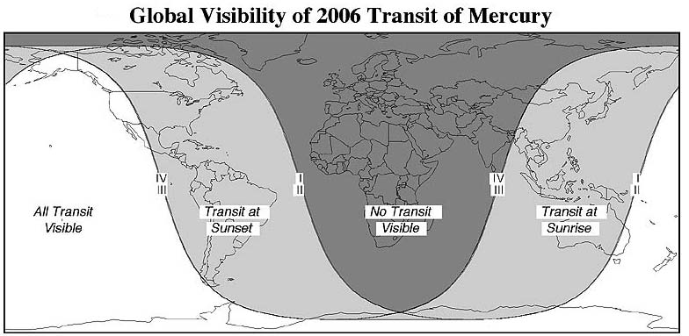

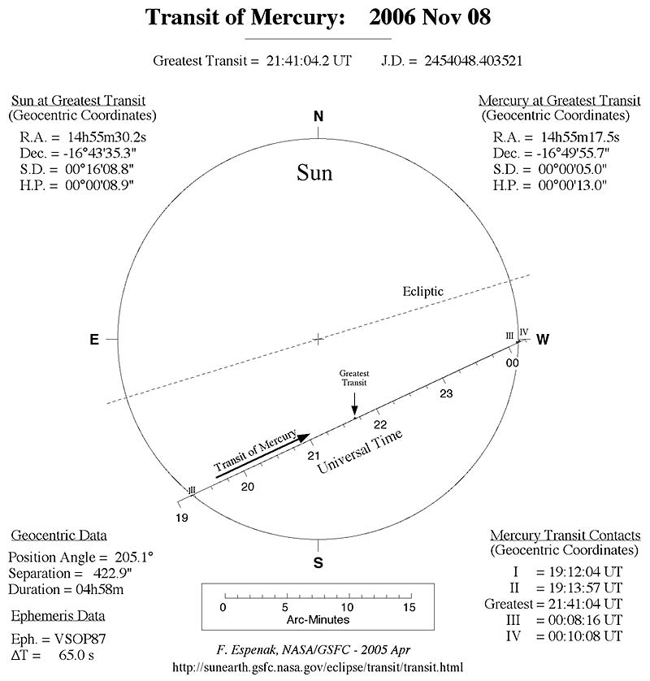

Few Facts about Planet Mercury:
Its diameter (4880 km) is 40% smaller than Earth and 40% larger than the Moon.
Mercury's day is 176 Earth days long and its year is 88 Earth days; that means a day on Mercury is two Mercury years long!
Since Mercury's rotation axis does not tilt as much as Earth's, the planet doesn't have seasons in the same way as we do on Earth.
Viewed from Mercury the Sun looks nearly three times as large as it does from Earth, and is up to 11 times brighter!
Mercury has a weak magnetic field.
The heavily cratered surface looks like the lunar surface.

Never ever observe Sun with naked eyes or with any optical instrument. It may cause permanent blindness. Only see the sun through projection method or with proper safe sun viewing filters. For images of last mercury transit, please visit our website at www.space-india.org/gallery. For further details log on to www.space-india.net

